HW-4

knitr::opts_chunk$set(echo = TRUE)

6.2

### for t = 10^4  
X <- vector()  
t <- 10^4  
X[1] = 0  
for(i in 2:t){  
 X[i] <- X[i-1] + rnorm(1,0,1)  
}  
  
plot(X,type="l")

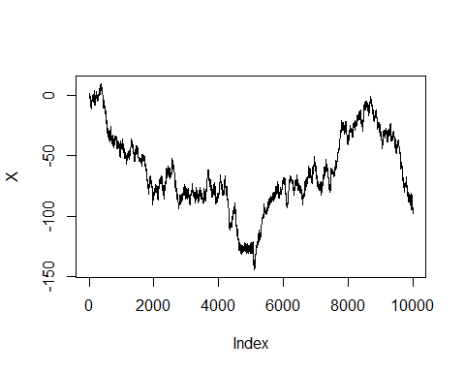

#Helps to see whether randomwalk is converging  
plot(cumsum(X),type="l")

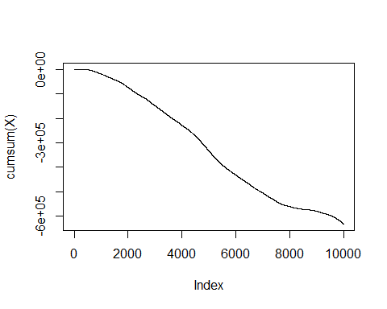

# A stationary probability distribution exists by construction  
# for those chains; that is, there exists a probability  
# distribution f such that if X(t) ∼ f , then X(t + 1) ∼ f

#Analyzing the last values of X we can determine whether stationary probability  
#exists for random walk  
  
tail(X)

## [1] -98.00294 -97.61150 -98.02811 -95.28978 -93.98828 -93.37919

#By looking at the last values of X we can determine that   
#random walk is not a stationary distribution  
  
# In a limiting distribution X(t) is f for almost any initial value X(0)  
# But in our current randomwalk simulation  
# we reach different X(t) value with the same initial value X(0)  
  
  
#By looking at the last values of X(t) we can determine that  
#random walk is not a limiting distribution

### for t = 10^6  
X <- vector()  
t <- 10^5  
X[1] = 0  
for(i in 2:t){  
 X[i] <- X[i-1] + rnorm(1,0,1)  
}  
  
plot(X,type="l")

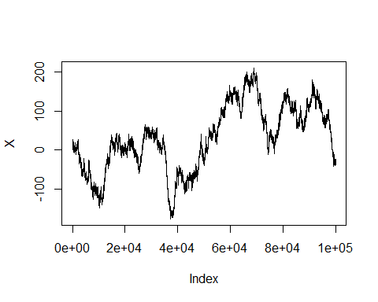

#Helps to see whether randomwalk is converging  
plot(cumsum(X),type="l")

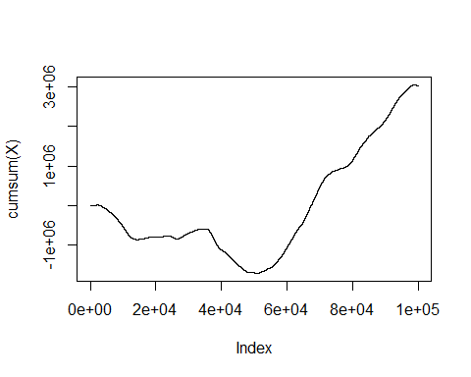

# A stationary probability distribution exists by construction  
# for those chains; that is, there exists a probability  
# distribution f such that if X(t) ∼ f , then X(t + 1) ∼ f

#Analyzing the last values of X we can determine whether stationary probability  
#exists for random walk  
  
tail(X)

## [1] -24.21118 -23.99085 -23.40403 -24.58683 -25.99946 -24.11550

#By looking at the last values of X we can determine that   
#random walk is not a stationary distribution  
  
# In a limiting distribution X(t) is f for almost any initial value X(0)  
# But in our current randomwalk simulation  
# we reach different X(t) value with the same initial value X(0)  
  
  
#By looking at the last values of X(t) we can determine that  
#random walk is not a limiting distribution

6.4 a

# When b = floor(alpha)/alpha

h <- function(x,a,b)  
{  
 dgamma(x,a,b) / dgamma(x,floor(a),floor(a)/a)   
}  
  
x <- seq(0,1,by=0.01)  
a = 2.5  
b = 1  
plot(x,h(x,a,b),type = "l")

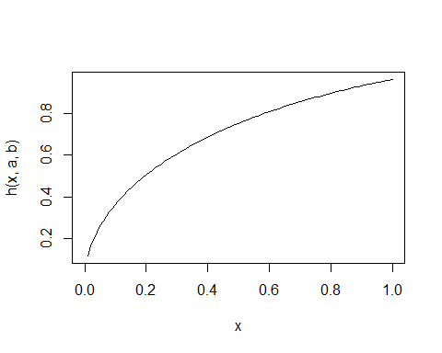

f <- function(x)  
{  
 dgamma(x,a,b) / dgamma(x,floor(a),floor(a)/a)   
}  
  
sim <- optimize(h(x,2.5,1), interval = c(0,1) , maximum = TRUE)  
sim.obj <- sim$objective  
M <- 0.96  
#M <- 1/sim.obj  
N <- 90000  
u <- runif(N,min = 0, max = M)  
y <- rgamma(N,a,b)  
x <- y[u < h(y,a,b)]  
hist(x,breaks = 40, prob = T)

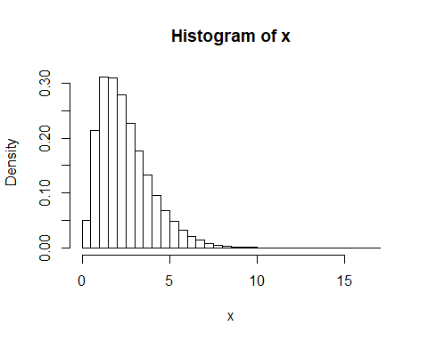

#Acceptance rate for with b = floor(a)/a  
length(x)/N

## [1] 0.9683333

# Without b = floor(alpha)/alpha

h <- function(x,a,b)  
{  
 dgamma(x,a,b) / dgamma(x,floor(a),floor(b))   
}  
  
x <- seq(0,1,by=0.01)  
a = 2.5  
b = 1  
plot(x,h(x,a,b),type = "l")

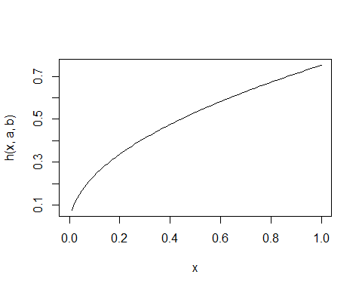

f <- function(x)  
{  
 dgamma(x,a,b) / dgamma(x,floor(a),floor(b))   
}  
  
sim <- optimize(h(x,2.5,1), interval = c(0,1) , maximum = TRUE)  
sim.obj <- sim$objective  
M <- 0.96  
#M <- 1/sim.obj  
N <- 90000  
u <- runif(N,min = 0, max = M)  
y <- rgamma(N,a,b)  
x <- y[u < h(y,a,b)]  
hist(x,breaks = 40, prob = T)

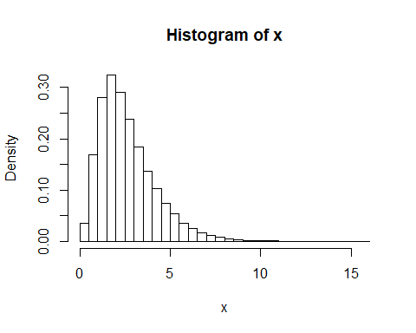

#Acceptance rate for b != floor(a)/a  
length(x)/N

## [1] 0.9236

# When b = floor(alpha)/alpha and Beta not equal to 1

h <- function(x,a,b)  
{  
 dgamma(x,a,b) / dgamma(x,floor(a),floor(a)/a)   
}  
  
x <- seq(0,1,by=0.01)  
a = 2.5  
b = 3.6  
plot(x,h(x,a,b),type = "l")

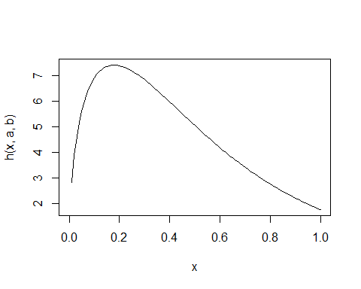

f <- function(x)  
{  
 dgamma(x,a,b) / dgamma(x,floor(a),floor(a)/a)   
}  
  
sim <- optimize(h(x,2.5,3.6), interval = c(0,1) , maximum = TRUE)  
sim.obj <- sim$objective  
M <- 0.56  
#M <- 1/sim.obj  
N <- 90000  
u <- runif(N,min = 0, max = M)  
y <- rgamma(N,a,b)  
x <- y[u < h(y,a,b)]  
hist(x,breaks = 40, prob = T)

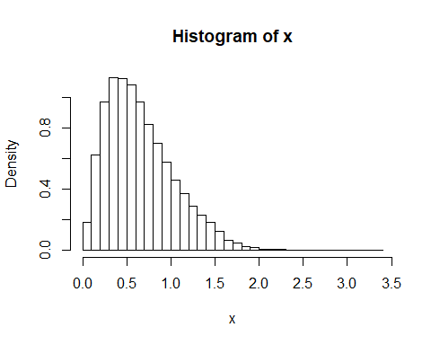

#Acceptance rate for with b = floor(a)/a when Beta not equal to 1  
length(x)/N

## [1] 0.9730667

# Without b = floor(alpha)/alpha

h <- function(x,a,b)  
{  
 dgamma(x,a,b) / dgamma(x,floor(a),floor(b))   
}  
  
x <- seq(0,1,by=0.01)  
a = 2.5  
b = 3.6  
plot(x,h(x,a,b),type = "l")

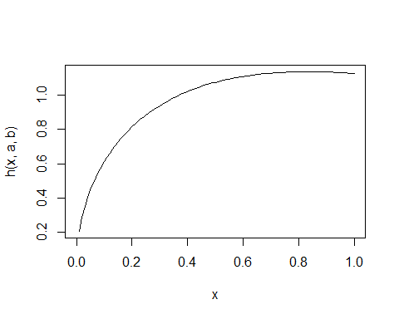

f <- function(x)  
{  
 dgamma(x,a,b) / dgamma(x,floor(a),floor(b))   
}  
  
sim <- optimize(h(x,2.5,3.6), interval = c(0,1) , maximum = TRUE)  
sim.obj <- sim$objective  
M <- 1.13  
#M <- 1/sim.obj  
N <- 90000  
u <- runif(N,min = 0, max = M)  
y <- rgamma(N,a,b)  
x <- y[u < h(y,a,b)]  
hist(x,breaks = 40, prob = T)  
c <- seq(0,3,0.01)  
lines(c,dgamma(c,a,b),type = "l")

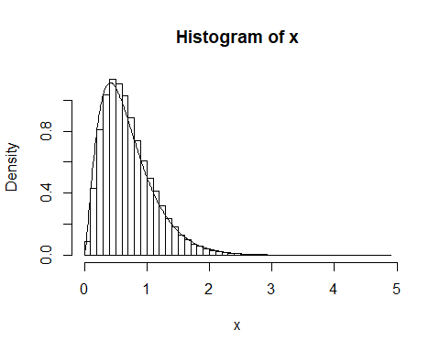

#Acceptance rate for b != floor(a)/a  
length(x)/N

## [1] 0.9065222

## The Acceptance rate is at 96.7% when b = floor(a)/a is used and 92.2% when not used. The acceptance rate is dropped to 0.11% when beta is not equal to 1 for b = floor(a)/a and 90.8% for b equal to floor(beta)

6.4 b

h <- function(x,a,b)  
{  
 dgamma(x,a,b) / dgamma(x,floor(a),floor(a)/a)   
}  
  
  
x <- seq(0,1,by=0.01)  
a = 4.85  
b = 1  
plot(x,h(x,a,b),type = "l")

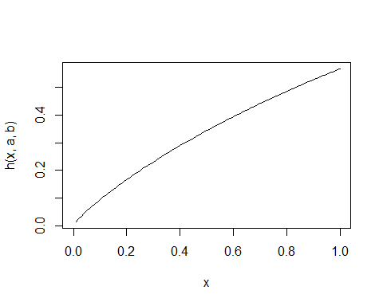

f <- function(x)  
{  
 dgamma(x,a,b) / dgamma(x,floor(a),floor(a)/a)   
}  
  
sim <- optimize(h(x,4.85,1), interval = c(0,1) , maximum = TRUE)  
sim.obj <- sim$objective  
M <- 0.56  
N <- 5000  
u <- runif(N,min = 0, max = M)  
y <- rgamma(N,4.85,1)  
#x <- y[u < h(y,4.85,1)]  
x <- y[u < rgamma(y,4.85,1)]  
hist(x,breaks = 40, prob = T)  
c <- seq(0,15,by = 0.01)  
lines(c,dgamma(c,4.85,1),type = "l")

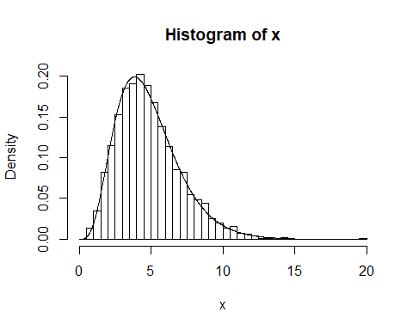

length(x)/N

## [1] 1

mean(x)

## [1] 4.887669

var(x)

## [1] 5.031518

pacf(x)

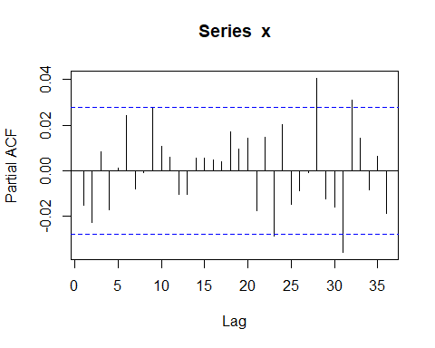

acf(x)

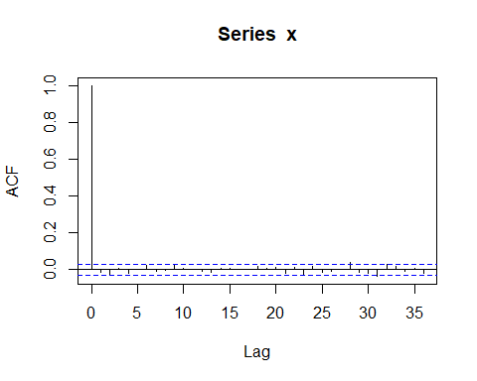

6.4 c

N <- 5000  
X<-rep(0,N)  
X[1]<-rgamma(1,4.85,1)  
for (i in 2:5000){  
 Y<-rgamma(1,4,4/4.85)  
 rho=(dgamma(X[i-1],4,4/4.85)*dgamma(Y,4.85,1))/(dgamma(Y,4,4/4.85)*dgamma(X[i-1],4.85,1))  
 X[i]=X[i-1]+(Y-X[i-1])*(runif(1)<rho)  
}  
  
length(unique(X))/N

## [1] 0.9358

mean(X)

## [1] 4.799567

var(X)

## [1] 4.795891

plot(X,type = "l")

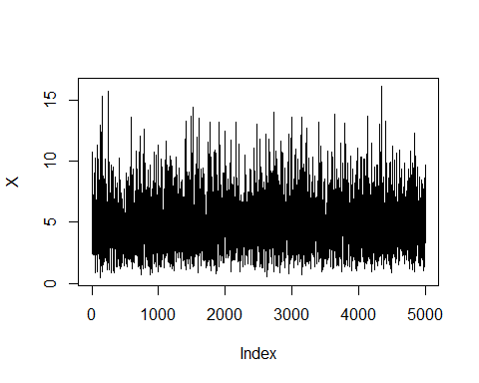

x<-seq(0,15, by=.01)  
y<-dgamma(x,4.85,4/4.85)  
hist(X,breaks = 40, prob = T)  
lines(x,y, type = "l")

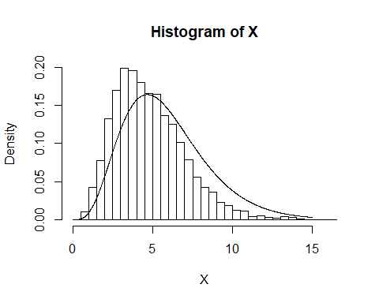

pacf(X)

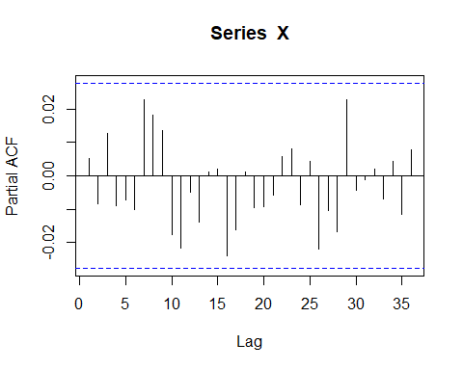

acf(X)

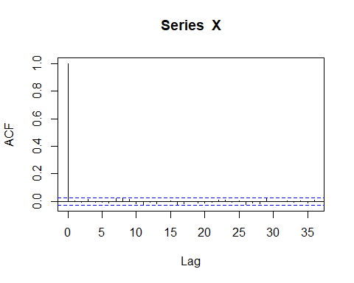

6.4 d

1. The acceptance rate for accept reject algorithm is 99% and there is no acceptance rate for Metropolis-Hastings algorithm since it is based on morkov-chain (random walk) that is if a value is rejected because of the condition previous value is copied to present value. But effeciency rate is around 93.38%

ii)Mean and Variance of accept-reject are as follows - 4.79 and 4.76 Mean and variance of Mtropolis - Hastings algorithm are - 4.9 and 4.9 With variance from metropolis we can deduct that values are vary with in a close range. Looking at a pacf and acf of metropolis we can observe the values generated from metropolis-hastings algorithm is correlated.

6.10 a

N= 5000  
X=rep(rnorm(1,0,1), N)  
n = 4  
for(i in 2:N){  
 Y=rnorm(1, 0, 1)   
 rho=(dt(Y,df=n)/dt(X[i-1], df= n))*(dnorm(Y, 0,1)/dnorm(X[i-1],0,1))  
 X[i]=X[i-1] + (Y-X[i-1])*(runif(1)<rho)   
}  
  
plot(X,type = "l")

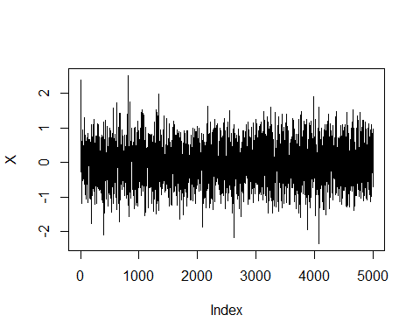

hist(X,breaks = 40, probability = TRUE)   
x<-seq(-3,3, by=.01)  
y<-dt(x,df=4)  
lines(x,y)

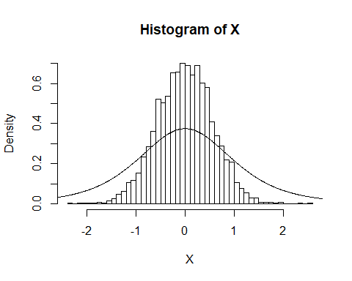

mean(X)

## [1] -0.004149037

#Mean of t-distibution is 0, oTherwise undefined. When calculating mean of all X, or accepted values   
#with candidate density N(0,1) for a target t-distribution with df = 4 mean is 0.007

6.10 b

N= 5000  
X=rep(rt(1,2), N)  
n = 4  
for(i in 2:N){  
 Y=rt(1,2)   
 rho=(dt(Y,df=n)/dt(X[i-1], df= n))*(dt(Y,2)/dt(X[i-1],2))  
 X[i]=X[i-1] + (Y-X[i-1])*(runif(1)<rho)  
}  
  
plot(X,type = "l")

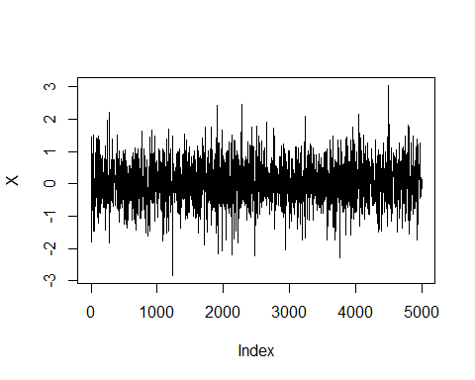

hist(X,breaks = 40, probability = TRUE, xlim = c(-4,4))  
x<-seq(-3,3, by=.01)  
y<-dt(x,df=4)  
lines(x,y)

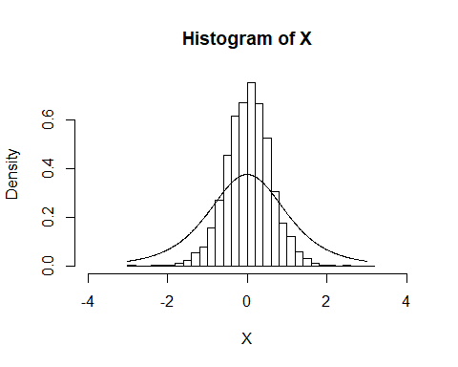

mean(X)

## [1] 0.03382485

#Mean of t-distibution is 0, otherwise undefined. When calculating mean of all X, or accepted values   
#with candidate denstity t and df = 2 for target t distribution and df = 4 mean is 0.117